I’m hoping to start some efforts that will align our school’s moral focus virtues with its use of resources, and in the process, help our school achieve the Michigan Green School Certificate.
Mrs. Morad, the Student Council, as well as several parents are already getting excited about the many ways we can implement simple solutions that make sense.

In order to be awarded the Michigan Green School Certificate, our school must complete either 10, 15 or 20 points on a checklist of events, programs, or lessons with environmental themes. (www.michigangreenschools.us)

Sounds like too much? The reality is that our school is already doing some ‘green’ things and we just need to document it. Also, many of the projects include awareness about animals, nature, and art, something that pretty much all kids enjoy.

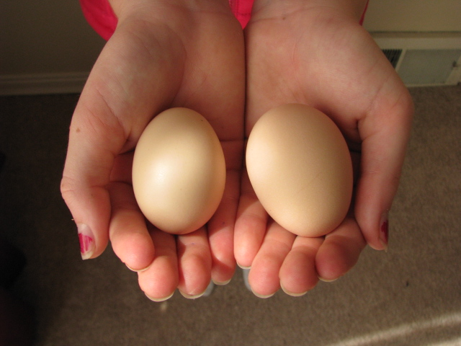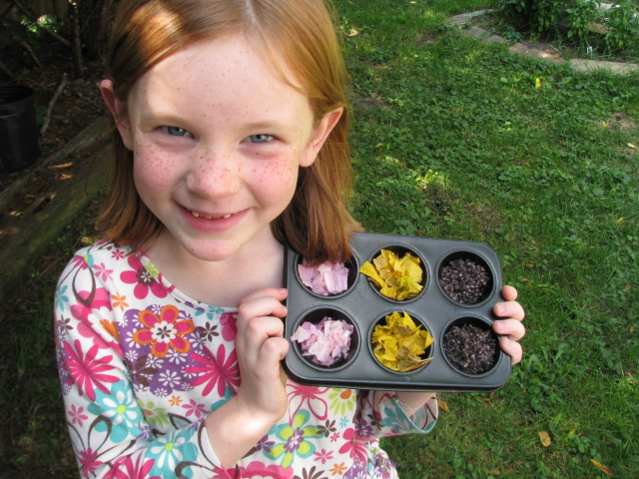

Furthermore, partnering with the school to step out in courage and wisdom regarding its treatment of the environment will empower our kids to make responsible choices that not only impact their future, but their present as well.

Just last week, my six-year old asked me how she could make the garbage dumps smaller. Last year, my older daughter asked why it’s so hard to breathe in the parking lot.
Kids are hungry to do good in the world.

May I suggest 10 checkpoints to get us started?

- Encourage office staff and teachers to be purposeful in creating only double sided documents for printing and copying.

- Revamp the paper/plastic recycling program and increase awareness about what can and cannot be recycled.

- Encourage the use of the uniform exchange option.

- Trash-Free Tuesdays in the lunchroom. Weigh lunch trash before and after introducing the program. Get aware!

- Compost food waste.

- Present a unit on alternative energy. (Are any teachers doing this already?)

- Promote fuel efficiency by discouraging idling in the parking lot, via parent surveys to increase awareness. (Hint: for every 2 minutes of idling, your car uses enough gas to drive 1 mile.)

- Host an alternative energy presentation or event, such as a Solar Cookout.

- Plant a themed garden (How about a Butterfly Garden in front of the new building addition?)

- Implement an animal habitat project (birdhouse, bat house, natural meadow).

Other ideas include: Upcycling foil wrap based consumables (Capri Sun), having a school-wide thermostat setting, student-made posters for the hall promoting environmental awareness, reference material visible in the media center, and encourage teachers add links to green sites in their newsletters or on their class websites, planting trees to offset our paper consumption, field trips to landfills or nature preserves, adopting an endangered species, art projects using repurposed items.

Other ideas are welcome!

Sincerely,

Keri Middaugh (mom to Abi and Josi)

